*Application Packaging*

1. Application packaging is the process of preparing software which can be easily installed, updated or removed on many computers together.
2. Any code needs to be converted into a software deployable package first.
3. Application packaging updates different versions of softwares which is also called as Software as a Service apps package.
4. IT teams use it to deploy apps quickly across multiple machines using tools like SCCM or Intune.
5. It helps by saving time and also ensures the same setup on all computers.

**Benefits of Application Packaging include:**

1. Ensures a consistent, stable and reliable standard environment.
2. Increases the efficiency of software management.
3. It lowers security issues.
4. Reduces risks for business disruption and vulnerabilities.

**End-to-End Application Packaging Process:**

End-to-End Packaging means handling the complete process of preparing an application for deployment from receiving the app to making it ready for installation across systems.

The steps include Identify & Collect, Review & Assess, Package, Test and Deploy.

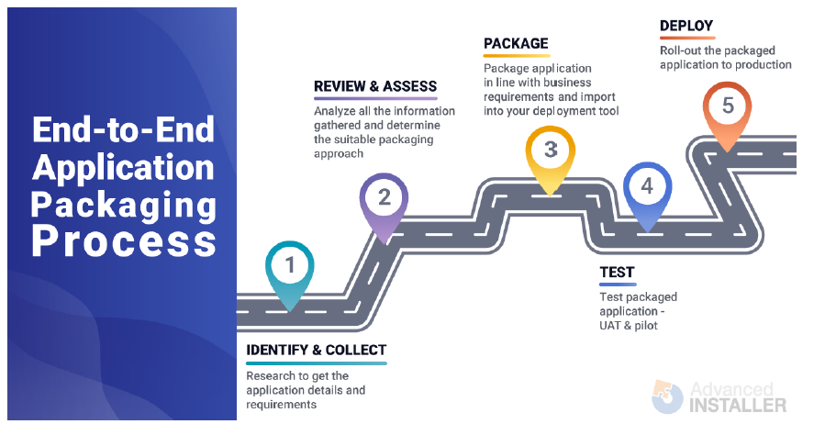

There are two main reasons why companies take this approach:

* To cut down costs.
* To improve app packaging process efficiency by speeding up the process and reducing the time an application takes to be packaged and deployed to production devices.

The downside of this approach is the difficulty to find the candidates with the right skills, and someone who fully understands the end-to-end packaging process.

**There are two main types of packaging:**

* Windows(Android)
* Mac

**Steps to install MSIX**

1. Click on Start Menu

2)Search for Microsoft Store and Open it

3)On the top search for “MSIX Packaging Tool”

4)Click on Get option (Blue coloured box)

5)After installing Click on Open

